A000-ASIA-Indus-Male Figurine-Three Male Nipples-Polos Headdress-Terracotta-3000 BCE

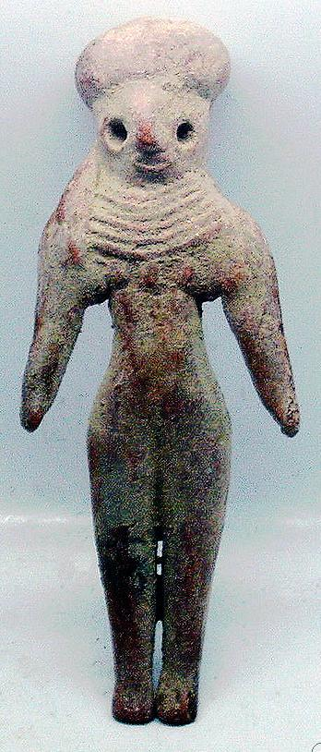 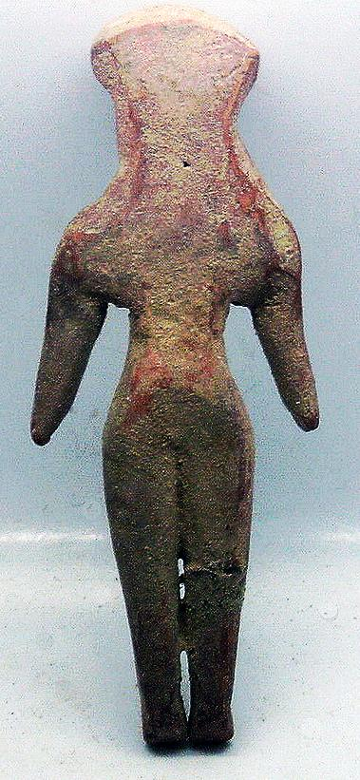

Fig. 1. Indus-Male Figurine-Three Male Nipples-Polos Headdress-Terracotta-3000 BCE

Case no.: 3.

Accession Number: A….

Formal Label: Indus-Male Figurine-Three Male Nipples-Polos Headdress-Terracotta-3000 BCE

**Display Description:**

This Indus male figurine has the unusual physical condition of having 3 male nipples. He wears a polos headdress which is usually reserved for women. He wears a six layered bib. His stylized facial features, long lappets of hair, which hang down on past the shoulders on the right, and long tapered legs end with delicate little feet with individual toes pointing downwards suggest a feminine aspect.

**LC Classification:** PK119

Date or Time Horizon: 3000 BCE

Geographical Area: Indus Valley

INCLUDEPICTURE "https://upload.wikimedia.org/wikipedia/commons/5/50/Carte_Indus.jpg" \* MERGEFORMATINET 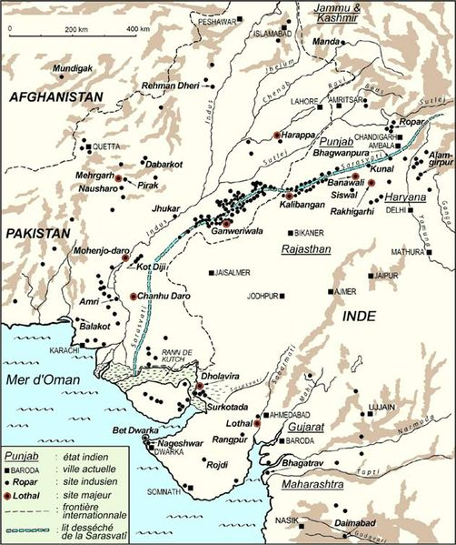

Cultural Affiliation: Indus

Media: terracotta, black pigment

Dimensions: H 10.1 cm.

Weight:

Condition: original

Provenance: Ex: European collection

**Discussion:**   
The following is Sharri R. Clark’s reference to nipples on Indus figurines:” The explicit and somewhat exaggerated depiction of nipples on the male figurines, a subtle physiological feature without reproductive importance, may provide some insight into conceptions of sex, gender, and sexuality in Indus society, especially given the relative crudeness of most of the terracotta figurines and the generally minimalist approach to representing the features of the body (for example, fingers and even eyes) in this medium. The nipples may be imbued with cultural and symbolic significance, mirroring the breasts not in physiological prominence or reproductive importance, but as a symbolic repository of male sex, gender, and sexuality. Perhaps non-Western ideology provides a better analogy (but not necessarily a direct explanation). For example, in later Vedic belief, notions of the hydraulic system of the human body require balance between the similar (and dangerous) body fluids (blood, milk-produced by both males and females-, and semen), and the fluids of the upper body are considered positive, while the fluids of the lower body are considered negative (O'Flaherty 1980: 55). In Tantric ritual, the control and retention of semen (through asceticism) is even believed to cause the yogi to turn his seed into milk and to develop ‘breasts’” (O'Flaherty 1980: 58) (Clark 2003).

**References:**

Clark, S.R. 2003. “Representing the Indus body: sex, gender, sexuality, and the anthropomorphic terracotta figurines from Harappa,” *Asian Perspectives*, *42*(2), pp.304-328.